2026 THEME– “GOD IS IN THE MIDST OF US’
By Pastor Claudia
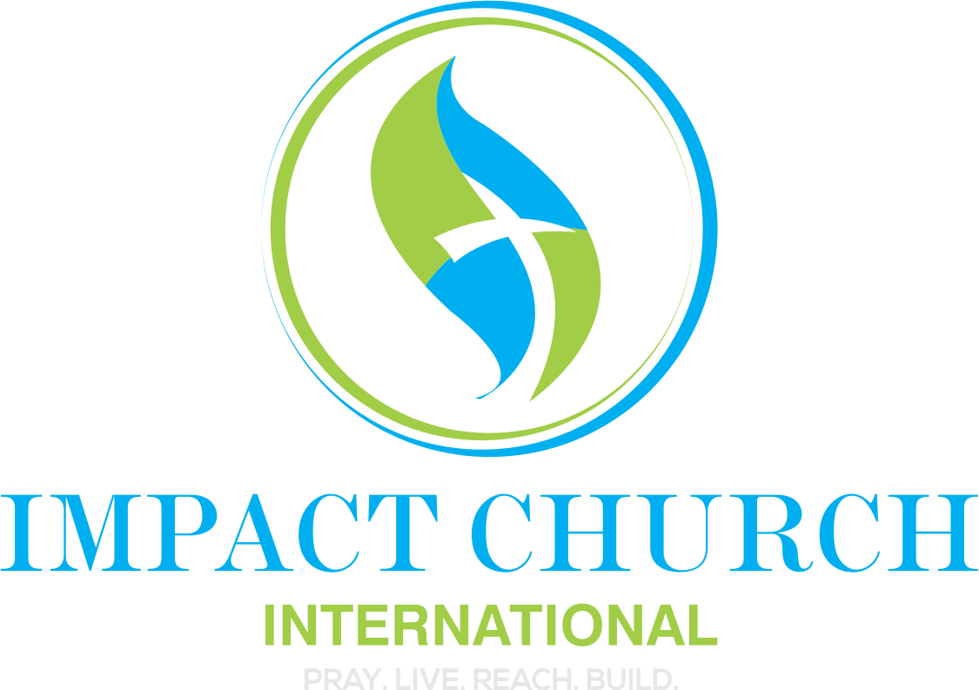

TOPIC: Introduction to the annual church theme: “God Is In The Midst of Us”

Scripture References:

Zephaniah 3:17a
¹⁷ The Lord thy God in the midst of thee is mighty; he will save, he will rejoice over thee with joy; “

Haggai 2:5

⁵ According to the word that I covenanted with you when ye came out of Egypt, so my spirit remaineth among you: fear ye not

Song: “I Come in the Volume of the Book” by Moses Akoh

When God TRULY is in the midst of us, several things happen:
When God is truly in the midst of us, things will happen—not by accident, but by divine intention. His presence brings order where there was confusion, peace where there was turmoil, and movement where there was stagnation. Situations shift, hearts are softened, and outcomes change because God is actively at work among His people. Fear loses its grip, faith is strengthened, and what once seemed impossible becomes possible. When God is TRULY in the midst, transformation is inevitable, because His presence carries power, purpose, and promise.
God wants to be in the midst of our
- Routines
- Decisions
- Work
- Family
- Finances
- Marriage
- Leadership
- Dating
- Parenting

When we say God wants to be in the midst of our lives, we are declaring that He is not meant to be an occasional visitor but the Governor at the center of everything. God does not exist to bless decisions we have already made—He exists to direct, order, and rule our lives according to Kingdom authority. When God is in the midst of our routines, decisions, work, family, finances, relationships, and leadership, our lives move from being reactive to being aligned. Confusion gives way to clarity, and disorder is replaced with divine structure.
When the King is in the middle, everything around Him must adjust. Ordinary moments become strategic, work becomes assignment, relationships become covenant, and resources come under stewardship instead of stress. God’s presence is not passive—it produces transformation. When He is truly in the midst, fear loses its voice, purpose becomes clear, and outcomes change, because the Kingdom is now governing our life and the situation.
There Were Several Moments in Scripture Where God Made His Presence Known.
- At the moment of transition or crisis, when what was and what will be collide. Examples:
  - Israel leaving Egypt – Exo 14 – 19
  - Daniel’s faith tested – Daniel 3
  - God’s judgement ends – restoration comes – Zephaniah 3: 15-17
- When the future cannot be reached without God
- When we’ve reached our limit:
  - Red Sea – Moses
  - Fire to hot – Hebrew boys
  - Sin too deep
  - Fear too strong
  - When you reach your limit:
• When everything feels heavy, even the small stuff
- When you’re tired but can’t rest
- When you’re reacting instead of responding
- When your patience is gone
- When you’re giving a lot but not receiving anything back
- When you feel stuck, numb, or disconnected from joy
- When you start saying “I can’t do this anymore” (even quietly)
- When prayer feels hard because you don’t have the words
- Something new is being established

