END OF 2025: WE STAND AND CRY HOLY, HOLY, HOLY
By Pastor Claudia
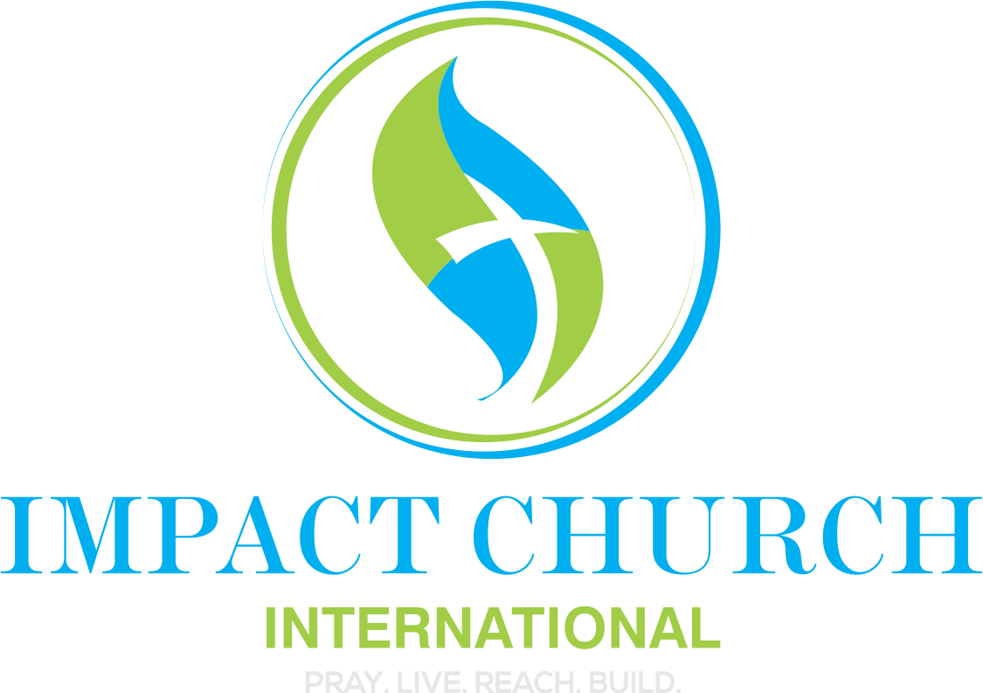

Song to Worship With As You Read These Notes: Dunsin Oyekin “The Glory Song” https://www.youtube.com/watch?v=fcO3FjVnFk4&list=RDfcO3FjVnFk4&start_radio=1

Scripture References:

Revelation 7:9–10 (ESV)
After this I looked, and behold, a great multitude that no one could number, from every nation, from all tribes and peoples and languages, standing before the throne and before the Lamb, clothed in white robes, with palm branches in their hands,
and crying out with a loud voice,
“Salvation belongs to our God who sits on the throne, and to the Lamb!”

Revelation 7:11 (ESV)
And all the angels were standing around the throne and around the elders and the four living creatures, and they fell on their faces before the throne and worshiped God,

Revelation 14:3 (ESV)
And they were singing a new song before the throne and before the four living creatures and before the elders. No one could learn that song except the 144,000 who had been redeemed from the earth.

Daniel 7:9–10 (ESV)
“As I looked,
thrones were placed,
and the Ancient of Days took his seat;
his clothing was white as snow,
and the hair of his head like pure wool;
his throne was fiery flames;
its wheels were burning fire.
A stream of fire issued
and came out from before him;
a thousand thousands served him,
and ten thousand times ten thousand stood before him;
the court sat in judgment,
and the books were opened.”

Revelation 4:8 (ESV)
And the four living creatures, each of them with six wings, are full of eyes all around and within, and day and night they never cease to say,
“Holy, holy, holy, is the Lord God Almighty,
who was and is and is to come!”

Isaiah 6:1–3 (ESV)
Above him stood the seraphim. Each had six wings: with two he covered his face, and with two he covered his feet, and with two he flew.
And one called to another and said:
“Holy, holy, holy is the LORD of hosts;
the whole earth is full of his glory!”
“Holy” is one of the most spoken words in heaven and one of the most misunderstood words on earth. In Hebrew holy is Qadosh, in Greek: Hagios
Holy means “set apart, distinct, other-than, belonging exclusively. When we cry holy we are declaring that God is:
- He is self-existent
- He is unchanging
- He is unrivaled
- He has absolute authority
- He has the final say
- He sets the standard
- He defines truth

For 2025 and 2026 when you cry HOLY, HOLY, HOLY you declare that:
- You refuse to drag old patterns forward
- You cross aligned not just hopeful
- You submit your future to God’s order
Don’t cross seasons sitting down, you cross seasons standing.
So today, in a prophetic gesture, I challenge you to stand right now! Stand to show that you agree with heaven. Stand to say that you want alignment. Stand today to take your position. Cast doubt aside!
You endured a lot in 2025. You endured:
- Pressures
- Pruning
- Processing
We don’t just step into 2025, but we cross over
We shout HOLY, HOLY HOLY
- Close the door on 2025
- Cut off what can’t go with you
- Sanctify the gate of 2026

The personal benefits to you when you STAND AND SHOUT HOLY
- You reset spiritual authority
- You remind the atmosphere who’s really in charge
- You get aligned before you advance. You wonder why things are taking so long… could it be that you are out of alignment?
- You prepare your character for your increase
- You give heaven permission to trust you with more
- Standing says: I’M READY
- Standing says: I’M SUBMITTED
YOU CAN NOT TRULY STAND BEFORE GOD AND STAY THE SAME. IF NOTHING SHIFTS IN YOU, GO BACK AND STAND AND SHOUT HOLY AGAIN UNTIL YOU FEEL THE POWER OF THE MOST HIGH!
CLOSE THE GATE OF 2025
OPEN THE GATE OF 2026
Job 42:56 said: “I have heard thee by the hearing of the ear, but NOW, my eye see you!

